Aim: To design and develop an Online Library Management System using HTML, CSS, and JavaScript that allows users to view available books, search for books, check book details, and manage basic book borrowing activities through a user-friendly interface.
Algorithm:
- Start the program and display the library home page.
- Create a navigation menu and a list of available books.
- Allow users to search for books by title, author, or category.
- Display the matching books and their availability.
- Allow users to select a book and perform the available library actions.
- Use JavaScript to handle user interactions and update the interface.
- Display the appropriate confirmation or status message.
- Stop the program.
Program:
<!DOCTYPE html>
<html lang="en">
<head>
<meta charset="UTF-8">
<meta name="viewport" content="width=device-width, initial-scale=1.0">
<title>Libra - Smart Library</title>

<style>
* {
margin: 0;
padding: 0;
box-sizing: border-box;
}
:root {
--navy: #172554;
--purple: #6d5dfc;
--bg: #f6f7fc;
--muted: #7b849e;
}
body {
font-family: "Segoe UI", Arial, sans-serif;
background: var(--bg);
color: #222b45;
}
.layout {
display: flex;
min-height: 100vh;
}
.sidebar {
width: 245px;
background: var(--navy);
color: white;
padding: 30px 20px;
flex-shrink: 0;
}
.logo {
font-size: 27px;
font-weight: 800;
margin-bottom: 45px;
}
.logo span { color: #a99eff; }
.nav-label {
color: #a6b2d4;
font-size: 12px;
letter-spacing: 2px;
margin: 25px 10px 15px;
}
.nav-item {
padding: 14px;
border-radius: 10px;
margin: 8px 0;
cursor: pointer;
color: #dbe3ff;
}
.nav-item.active, .nav-item:hover {
background: #384779;
color: white;
}
.sidebar-note {
margin-top: 60px;
padding: 17px;
background: #263766;
border-radius: 14px;
line-height: 1.6;
font-size: 13px;
}
main {
flex: 1;
min-width: 0;
padding: 32px;
}
.topbar {
display: flex;
justify-content: space-between;
align-items: center;
gap: 15px;
margin-bottom: 28px;
}
.topbar h1 { font-size: 27px; }
.topbar p { color: var(--muted); margin-top: 6px; }
.profile {
background: white;
padding: 11px 15px;
border-radius: 30px;
white-space: nowrap;
box-shadow: 0 5px 20px #20284b08;
}
.hero {
background: linear-gradient(115deg, #4e46d9, #8a76ff);
color: white;
border-radius: 22px;
padding: 32px;
display: flex;
justify-content: space-between;
align-items: center;
gap: 20px;
overflow: hidden;
margin-bottom: 25px;
}
.hero h2 {
font-size: clamp(23px, 3vw, 34px);
margin-bottom: 12px;
}
.hero p {
color: #e8e6ff;
line-height: 1.7;
}
.hero-art {
font-size: 80px;
padding: 10px;
}
button {
cursor: pointer;
border: none;
border-radius: 9px;
padding: 12px 16px;
font-weight: 600;
transition: .2s;
}
button:hover { transform: translateY(-2px); }
.primary {
background: #fff;
color: #5043d2;
margin-top: 18px;
}
.stats {
display: grid;
grid-template-columns: repeat(4, minmax(0, 1fr));
gap: 17px;
margin-bottom: 30px;
}
.stat {
padding: 22px;
background: white;
border-radius: 16px;
box-shadow: 0 6px 24px #20284b06;
}
.stat-icon {
width: 43px;
height: 43px;
display: grid;
place-items: center;
border-radius: 12px;
font-size: 21px;
margin-bottom: 17px;
}
.stat small { color: var(--muted); }
.stat h2 { font-size: 29px; margin-top: 7px; }
.section-head {
display: flex;
justify-content: space-between;
align-items: center;
gap: 15px;
margin-bottom: 18px;
}
.section-head p {
color: var(--muted);
font-size: 14px;
margin-top: 6px;
}
.controls {
display: flex;
gap: 10px;
margin-bottom: 20px;
}
input, select {
padding: 12px;
border: 1px solid #e0e4ef;
border-radius: 9px;
background: white;
font: inherit;
min-width: 0;
}
#search { flex: 1; }
.add-btn { background: var(--purple); color: white; }
.book-grid {
display: grid;
grid-template-columns: repeat(3, minmax(0, 1fr));
gap: 20px;
}
.book {
background: white;
border-radius: 17px;
padding: 18px;
box-shadow: 0 6px 24px #20284b07;
min-width: 0;
}
.cover {
height: 165px;
border-radius: 12px;
display: grid;
place-items: center;
font-size: 67px;
margin-bottom: 17px;
}
.c1 { background: linear-gradient(135deg,#fce7c7,#f9bb8c); }
.c2 { background: linear-gradient(135deg,#dcd9ff,#aaa0ff); }
.c3 { background: linear-gradient(135deg,#c9f1e5,#7bd8bc); }
.c4 { background: linear-gradient(135deg,#fbd5e5,#f7a8c6); }
.c5 { background: linear-gradient(135deg,#d6e8ff,#9cc5ff); }
.c6 { background: linear-gradient(135deg,#f6edbb,#e7d76d); }
.book h3 { font-size: 17px; margin-bottom: 7px; }
.author { color: var(--muted); font-size: 13px; }
.book-meta {
display: flex;
justify-content: space-between;
align-items: center;
margin: 15px 0;
gap: 6px;
font-size: 12px;
}
.status {
background: #e3f8ee;
color: #13865c;
padding: 6px 9px;
border-radius: 20px;
}
.status.out {
background: #fff0d8;
color: #a76508;
}
.book-actions { display: flex; gap: 7px; }
.book-actions button { flex: 1; font-size: 12px; padding: 10px 5px; }
.issue { background: #ece9ff; color: #5b4ad6; }
.return { background: #e0f7ec; color: #16865c; }
.delete { background: #ffe7e7; color: #c43b48; }
#empty {
display: none;
background: white;
padding: 30px;
text-align: center;
border-radius: 12px;
color: var(--muted);
}
footer {
text-align: center;
color: var(--muted);
padding: 30px 0 5px;
font-size: 13px;
}
dialog {
width: min(420px, calc(100% - 30px));
margin: auto;
border: none;
border-radius: 18px;
padding: 25px;
box-shadow: 0 20px 80px #17255440;
}
dialog::backdrop { background: #111a3877; }
dialog h2 { margin-bottom: 18px; }
dialog input, dialog select { width: 100%; margin-bottom: 12px; }
.form-actions { display: flex; gap: 10px; }
.form-actions button { flex: 1; }
.cancel { background: #edf0f7; color: #27324c; }
#toast {
position: fixed;
bottom: 25px;
right: 25px;
padding: 15px 22px;
background: #172554;
color: white;
border-radius: 10px;
display: none;
box-shadow: 0 8px 25px #0002;
z-index: 5;
}
@media(max-width:1100px) {
.sidebar { width: 200px; }
.book-grid { grid-template-columns: repeat(2, minmax(0,1fr)); }
.stats { grid-template-columns: repeat(2, minmax(0,1fr)); }
}
@media(max-width:700px) {
.layout { display: block; }
.sidebar { width: 100%; padding: 18px; }
.logo { margin: 0 0 15px; }
.nav-label, .sidebar-note { display: none; }
.nav-item { display: inline-block; margin: 3px; padding: 10px; font-size: 13px; }
main { padding: 18px; }
.topbar { align-items: flex-start; flex-direction: column; }
.hero { padding: 23px; }
.hero-art { font-size: 45px; }
.book-grid { grid-template-columns: 1fr; }
.controls { flex-wrap: wrap; }
#search { flex-basis: 100%; }
}
</style>
</head>
<body>

<div class="layout">
<aside class="sidebar">
<div class="logo">📚 libr<span>a.</span></div>
<div class="nav-label">WORKSPACE</div>
<div class="nav-item active" onclick="showSection('all',this)">▦ &nbsp; Dashboard</div>
<div class="nav-item" onclick="showSection('available',this)">📗 &nbsp; Available Books</div>
<div class="nav-item" onclick="showSection('issued',this)">📤 &nbsp; Issued Books</div>
<div class="nav-label">MANAGEMENT</div>
<div class="nav-item" onclick="openForm()">＋ &nbsp; Add New Book</div>
<div class="nav-item" onclick="exportData()">⇩ &nbsp; Export Library</div>
<div class="sidebar-note">
✨ <b>Your knowledge hub</b><br>
Every book opens a new world. Keep learning, one page at a time.
</div>
</aside>

<main>
<div class="topbar">
<div>
<h1>Library Dashboard</h1>
<p>Welcome back! Here's what's happening in your library.</p>
</div>
<div class="profile">👤 &nbsp; Library Admin</div>
</div>

<section class="hero">
<div>
<h2>Discover your next<br>great adventure.</h2>
<p>Explore your collection, find new favourites,<br>and keep every story within reach.</p>
<button class="primary" onclick="openForm()">＋ Add a New Book</button>
</div>
<div class="hero-art">📖✨</div>
</section>

<section class="stats">
<div class="stat">
<div class="stat-icon" style="background:#ece9ff">📚</div>
<small>Book Titles</small><h2 id="titles">0</h2>
</div>
<div class="stat">
<div class="stat-icon" style="background:#e0f7ec">📗</div>
<small>Total Copies</small><h2 id="copies">0</h2>
</div>
<div class="stat">
<div class="stat-icon" style="background:#fff0d8">📤</div>
<small>Issued Copies</small><h2 id="issued">0</h2>
</div>
<div class="stat">
<div class="stat-icon" style="background:#dceeff">✅</div>
<small>Available Copies</small><h2 id="available">0</h2>
</div>
</section>

<section>
<div class="section-head">
<div>
<h2>Explore Collection</h2>
<p>Browse, search and manage your favourite books.</p>
</div>
</div>

<div class="controls">
<input id="search" placeholder="🔍 Search title or author..." oninput="renderBooks()">
<select id="category" onchange="renderBooks()">
<option value="all">All books</option>
<option value="available">Available</option>
<option value="issued">Currently issued</option>
</select>
<button class="add-btn" onclick="openForm()">＋ Add Book</button>
</div>

<div id="bookGrid" class="book-grid"></div>
<div id="empty">📚<br><br>No books found. Try another search or add a book.</div>
</section>

<footer>Made with ♥ for curious minds · Libra Library System</footer>
</main>
</div>

<dialog id="bookDialog">
<h2>Add a Book</h2>
<form id="addForm">
<input id="title" placeholder="Book title" required maxlength="100">
<input id="author" placeholder="Author name" required maxlength="100">
<input id="quantity" type="number" min="1" max="10000"
placeholder="Number of copies" required>
<select id="cover">
<option value="c1">Warm orange cover</option>
<option value="c2">Purple cover</option>
<option value="c3">Mint green cover</option>
<option value="c4">Pink cover</option>
<option value="c5">Blue cover</option>
<option value="c6">Golden cover</option>
</select>
<div class="form-actions">
<button type="button" class="cancel" onclick="bookDialog.close()">Cancel</button>
<button type="submit" class="add-btn">Save Book</button>
</div>
</form>
</dialog>

<div id="toast" role="status" aria-live="polite"></div>

<script>
const starterBooks = [
{id:1,title:"The Alchemist",author:"Paulo Coelho",quantity:5,available:4,cover:"c1",emoji:"🧭"},
{id:2,title:"Atomic Habits",author:"James Clear",quantity:4,available:4,cover:"c2",emoji:"⚡"},
{id:3,title:"Clean Code",author:"Robert C. Martin",quantity:3,available:2,cover:"c3",emoji:"💻"},
{id:4,title:"Pride and Prejudice",author:"Jane Austen",quantity:6,available:6,cover:"c4",emoji:"🌹"},
{id:5,title:"Deep Work",author:"Cal Newport",quantity:4,available:3,cover:"c5",emoji:"🎯"},
{id:6,title:"Think and Grow Rich",author:"Napoleon Hill",quantity:2,available:2,cover:"c6",emoji:"💡"}
];

let books = [];
try {
const saved = localStorage.getItem("libraCreativeBooks");
books = saved ? JSON.parse(saved) : starterBooks.map(b => ({...b}));
if (!Array.isArray(books)) books = starterBooks.map(b => ({...b}));
} catch {
books = starterBooks.map(b => ({...b}));
}

let nextId = books.reduce((max,b) => Math.max(max, Number(b.id)||0),0)+1;
let activeSection = "all";

const bookDialog = document.getElementById("bookDialog");

function persist() {
try {
localStorage.setItem("libraCreativeBooks",JSON.stringify(books));
return true;
} catch {
toast("Could not save data in this browser.");
return false;
}
}

function toast(message) {
const el = document.getElementById("toast");
el.textContent = message;
el.style.display = "block";
clearTimeout(window.toastTimer);
window.toastTimer = setTimeout(() => el.style.display="none",2500);
}

function updateStats() {
const total = books.reduce((s,b)=>s+b.quantity,0);
const available = books.reduce((s,b)=>s+b.available,0);
document.getElementById("titles").textContent = books.length;
document.getElementById("copies").textContent = total;
document.getElementById("available").textContent = available;
document.getElementById("issued").textContent = total-available;
}

function renderBooks() {
const query = document.getElementById("search").value.toLowerCase().trim();
const category = document.getElementById("category").value;
const grid = document.getElementById("bookGrid");
grid.replaceChildren();

const filtered = books.filter(b => {
const matches = b.title.toLowerCase().includes(query) ||
b.author.toLowerCase().includes(query);
const categoryMatches =
category==="all" ||
(category==="available" && b.available>0) ||
(category==="issued" && b.available<b.quantity);
const sectionMatches =
activeSection==="all" ||
(activeSection==="available" && b.available>0) ||
(activeSection==="issued" && b.available<b.quantity);
return matches && categoryMatches && sectionMatches;
});

filtered.forEach(b => {
const card = document.createElement("article");
card.className = "book";

const cover = document.createElement("div");
cover.className = "cover " + b.cover;
cover.textContent = b.emoji || "📖";

const title = document.createElement("h3");
title.textContent = b.title;

const author = document.createElement("p");
author.className = "author";
author.textContent = "by " + b.author;

const meta = document.createElement("div");
meta.className = "book-meta";

const status = document.createElement("span");
status.className = "status" + (b.available===0?" out":"");
status.textContent = b.available===0 ? "All issued" : "Available";

const count = document.createElement("span");
count.textContent = b.available + " / " + b.quantity + " copies";

meta.append(status,count);

const actions = document.createElement("div");
actions.className = "book-actions";

function action(label, cls, callback) {
const btn = document.createElement("button");
btn.className = cls;
btn.textContent = label;
btn.onclick = callback;
actions.appendChild(btn);
}

if (b.available > 0) {
action("Issue","issue",()=>changeCopies(b.id,-1));
}
if (b.available < b.quantity) {
action("Return","return",()=>changeCopies(b.id,1));
}
action("Delete","delete",()=>removeBook(b.id));

card.append(cover,title,author,meta,actions);
grid.appendChild(card);
});

document.getElementById("empty").style.display =
filtered.length ? "none" : "block";

updateStats();
}

function openForm() {
bookDialog.showModal();
}

document.getElementById("addForm").addEventListener("submit",e=>{
e.preventDefault();

const title = document.getElementById("title").value.trim();
const author = document.getElementById("author").value.trim();
const quantity = Number(document.getElementById("quantity").value);

if (!title || !author || !Number.isSafeInteger(quantity) ||
quantity<1 || quantity>10000) {
toast("Please enter valid book details.");
return;
}

const oldBooks = books;
books = [...books,{
id:nextId,
title,
author,
quantity,
available:quantity,
cover:document.getElementById("cover").value,
emoji:"📖"
}];

if (!persist()) {
books = oldBooks;
return;
}

nextId++;
e.target.reset();
bookDialog.close();
renderBooks();
toast("Book added to your collection!");
});

function changeCopies(id,change) {
const b = books.find(book=>book.id===id);
if (!b) return;

if (change<0 && b.available<=0) {
toast("No copies available.");
return;
}
if (change>0 && b.available>=b.quantity) {
toast("No issued copies to return.");
return;
}

b.available += change;
if (!persist()) {
b.available -= change;
return;
}

renderBooks();
toast(change<0 ? "Book issued successfully!" : "Book returned successfully!");
}

function removeBook(id) {
const b = books.find(book=>book.id===id);
if (!b) return;

if (b.available<b.quantity) {
toast("Return all issued copies before deleting.");
return;
}

if (!confirm("Delete \""+b.title+"\" from the library?")) return;

const oldBooks = books;
books = books.filter(book=>book.id!==id);

if (!persist()) {
books = oldBooks;
return;
}

renderBooks();
toast("Book removed from the collection.");
}

function showSection(section,element) {
activeSection = section;
document.querySelectorAll(".nav-item").forEach(item=>item.classList.remove("active"));
if (element) element.classList.add("active");

document.getElementById("category").value = "all";
document.getElementById("search").value = "";
renderBooks();

document.querySelector(".section-head h2").textContent =
section==="all" ? "Explore Collection" :
section==="available" ? "Available Books" : "Issued Books";

if (window.innerWidth<700) {
document.querySelector(".section-head").scrollIntoView({behavior:"smooth"});
}
}

function exportData() {
const blob = new Blob([JSON.stringify(books,null,2)],{type:"application/json"});
const url = URL.createObjectURL(blob);
const a = document.createElement("a");
a.href = url;
a.download = "library-books.json";
a.click();
URL.revokeObjectURL(url);
toast("Library data exported!");
}

renderBooks();
</script>
</body>
</html>
Output:
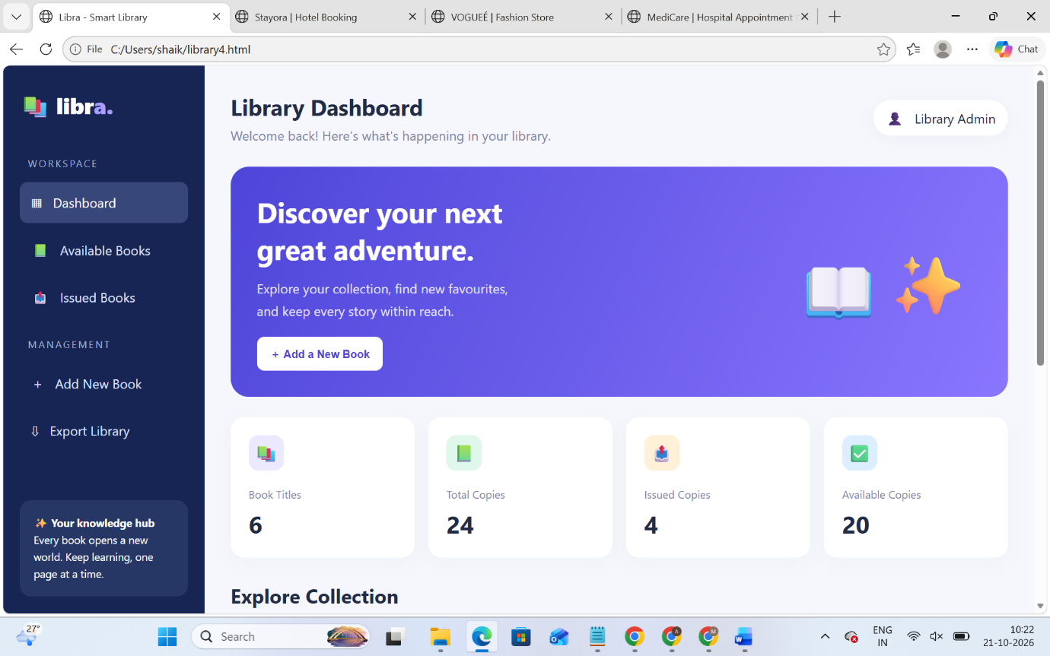
Result: Thus, the Online Library Management System was designed and developed successfully using HTML, CSS, and JavaScript. The system provides an interactive interface for searching books and managing basic library activities.

